For adding new node into existing ag cluster

After configuring new node on windows cluster.

1 Take a full backup and log backup and restore It on new node in restoring mode.

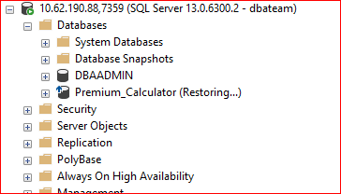

2 Connect primary server and expand “Always On High Availability”

3 Right click on Always On Group and click on “Add New Replica”

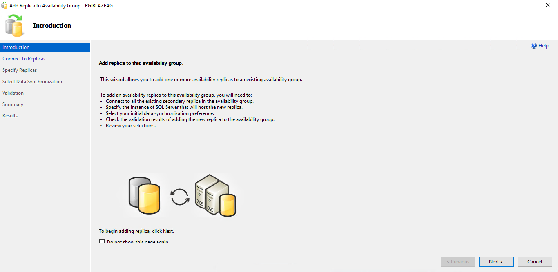

4 Click on Next and connect all existing secondary replicas.

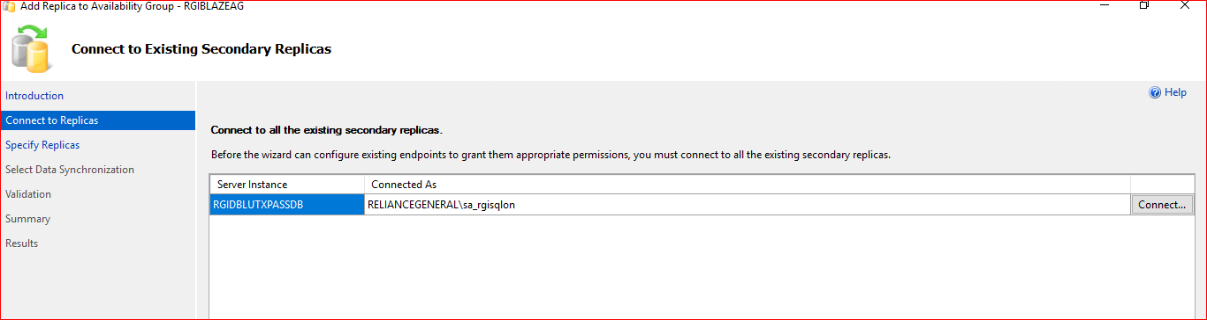

5 on next tab, add new replica by clicking “Add Replica” which you want to add in existing ag.

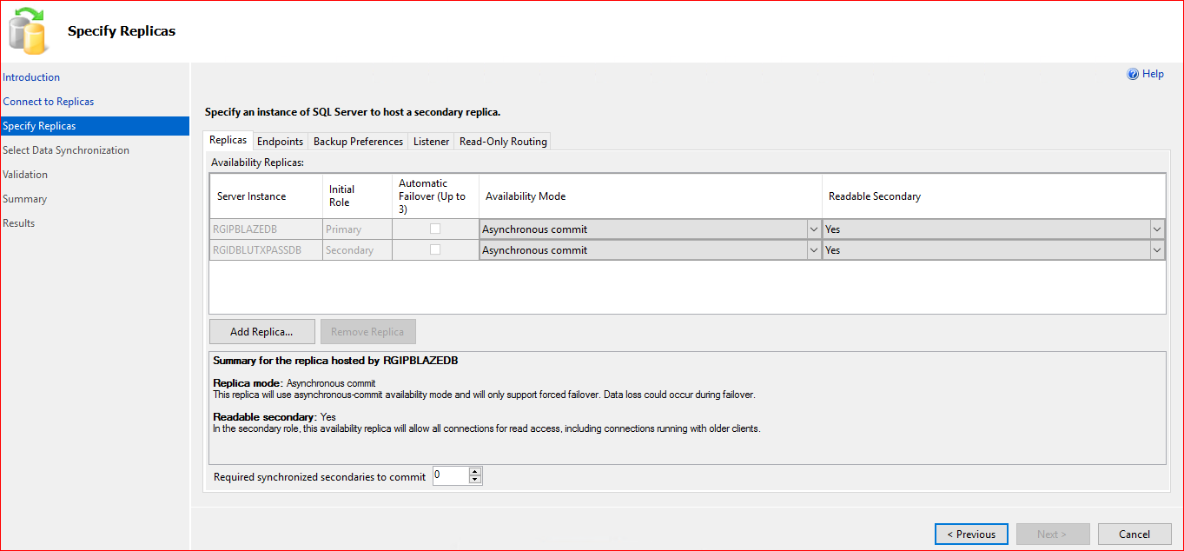

6 Connect New node and click ok. Also change any configuration of newly added replica If applicable.

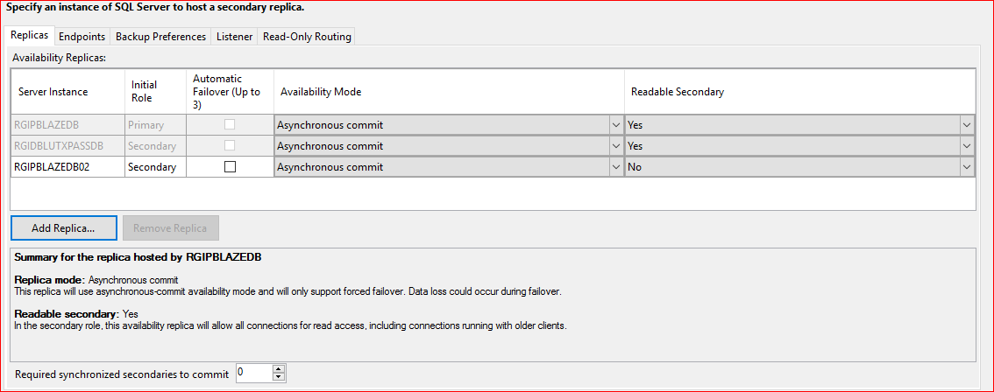

7 Select data initialization type as per requirement

